WEST END AT WAR

Soho air raid reports
  - Archive recovery and transcription dossier
Scope
Soho incidents, with two requested exceptions for the Café de Paris and Al Bowlly
Prepared 16 September 2026

How to use this dossier
This is an editable working record of material recovered from archived West End at War pages. It separates three evidence types: the website author’s incident narrative, surviving report-form images, and later visitor recollections. A form transcription records only what can reasonably be read from the preserved image. Square brackets mark editorial uncertainty or an unreadable word.
Archive limitation The Wayback Machine generally retained small web display copies rather than full-resolution originals. They are adequate for layout study and partial transcription, but not for forensic handwriting identification.

Recovery inventory
Incident | Date | Recovered material | Status
Old Compton Street and Dean Street | 11 May 1941 | 2 report forms | Good partial transcription
St Anne’s Church and Queen’s Theatre | 24 September and 7 October 1940 | 4 report forms | Mixed legibility
24 Greek Street | 11 October 1940 | 3 report forms | One very faint form
Carlisle Street | 11 and 13 May 1941 | 2 message forms | Strong transcription
St James’s Residences Brewer Street | 26 October 1940 | 2 of 3 listed forms | One archive image missing
Shaftesbury Avenue Fire Station | 7 October and 16 November 1940 | 2 records | Strong transcription
Café de Paris | 8 March 1941 | Narrative page only | No report form found
Jermyn Street and Al Bowlly | 17 April 1941 | 4 forms | Good partial transcription

Old Compton Street and Dean Street
  - 11 May 1941 approximately 03:47 onward
The archived account places a high-explosive bomb at the junction of Old Compton Street and Dean Street. Numbers 59 and 60 Dean Street, including Patisserie Valerie, were destroyed. Early messages reported more than forty people trapped. Fire seriously obstructed rescue work; the site account records fifteen fatalities removed.
Archive source West End at War archived incident page

Surviving forms
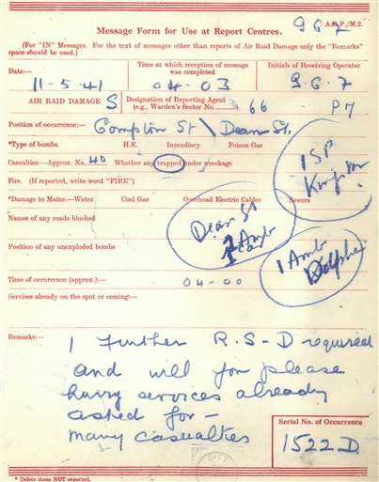  Occurrence 1522D | 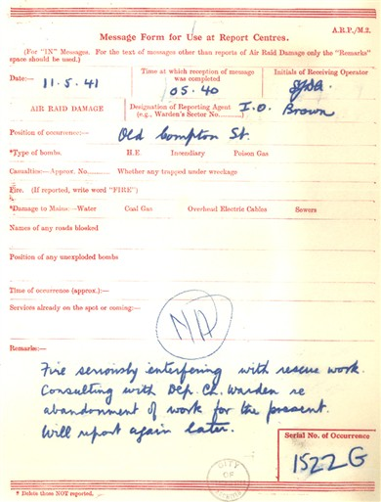  Occurrence 1522G

Recorded details

Occurrence 1522D
Field | Transcription or reading
Date | 11 May 1941
Receipt | 04:03
Position | Old Compton Street / Dean Street
Bomb type | High explosive
Casualties | Approximately 40 trapped
Remarks | [One further rescue squad] required; “please hurry”; services already asked for; many casualties [partly unclear].

Occurrence 1522G
Field | Transcription or reading
Date | 11 May 1941
Receipt | 05:40
Reporting agent | F O Brown
Position | Old Compton Street
Bomb type | High explosive
Remarks | “Fire seriously interfering with rescue work. Consulting with Dep. Ch. Warden re abandonment of work for the present. Will report again later.”

The quoted remarks on occurrence 1522G are the clearest surviving warden-style operational report in this group.

St Anne’s Church and Queen’s Theatre
  - 24 September 1940 and 7 October 1940
The archived page records two high-explosive bombs at about 23:38 on 24 September, severe fire and structural damage, and three casualties. Ambulance activity continued into the morning of 25 September, when fire was reported to have broken out again. Incendiaries struck the church on 7 October without casualties.
Archive source West End at War archived incident page

Surviving forms
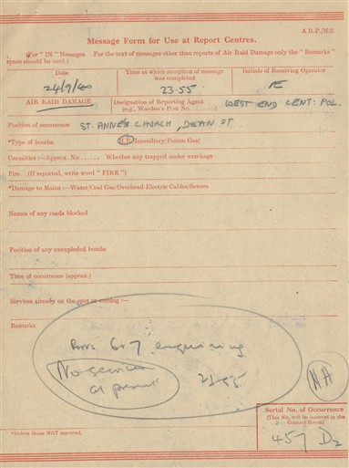  St Anne’s Church 24 September | 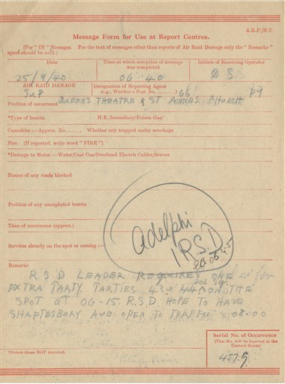  Queen’s Theatre 25 September
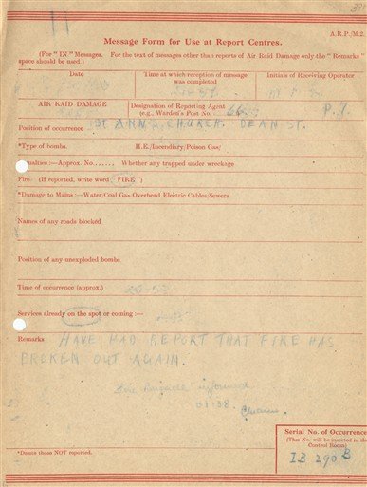  Fire broken out again | 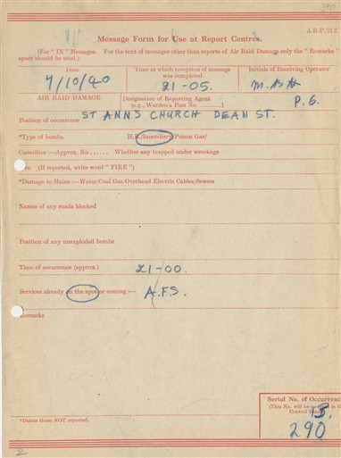  St Anne’s Church 7 October

Recorded details

St Anne’s Church
Field | Transcription or reading
Date | 24 September 1940
Receipt | 23:55
Position | St Anne’s Church, Dean Street
Bomb type | High explosive [reading probable]
Remarks | Handwriting too faint for a dependable full transcription.

Queen’s Theatre and St Anne’s Church
Field | Transcription or reading
Date | 25 September 1940
Receipt | 06:40
Position | Queen’s Theatre and St Anne’s Church
Remarks | Rescue squad leader reports an extra party; parties [unclear] at 06:15; hopes to have Shaftesbury Avenue open to traffic at 08:00 [partial reading].

Renewed fire
Field | Transcription or reading
Date | [Unreadable]
Receipt | Approximately 01:38
Position | St Anne’s Church, Dean Street
Remarks | “Have had report that fire has broken out again.”

Incendiary report
Field | Transcription or reading
Date | 7 October 1940
Receipt | 21:15
Position | St Anne’s Church, Dean Street
Bomb type | Incendiary
Occurrence | Approximately 21:00
Service | A F S

24 Greek Street
  - 11 October 1940 00:35 onward
A high-explosive bomb caused major damage at 24 Greek Street. The site narrative records a gas-main fire, blocked approaches at Greek Street and Old Compton Street, trapped casualties, and requests for rescue, stretcher-bearer and demolition resources.
Archive source West End at War archived incident page

Surviving forms
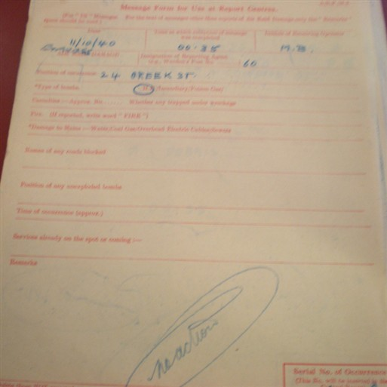  First report, badly faded | 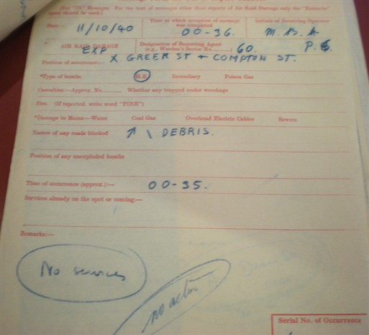  Greek Street and Old Compton Street
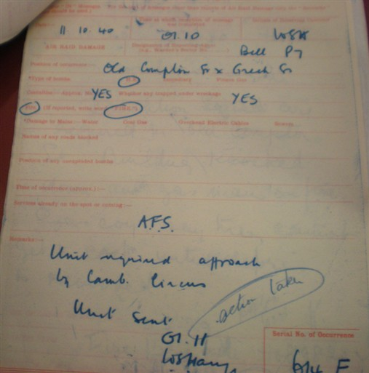
Later casualty and fire report

Recorded details

First report
Field | Transcription or reading
Date | 11 October 1940
Position | 24 Greek Street
Bomb type | High explosive
Remarks | The surviving web image is too faint for a responsible reading of the remarks.

Road obstruction report
Field | Transcription or reading
Date | 11 October 1940
Receipt | 00:36
Position | Greek Street × Old Compton Street
Bomb type | High explosive
Roads blocked | One, by debris
Occurrence | 00:35
Remarks | “No services” and “no action” are circled.

Casualty and fire report
Field | Transcription or reading
Date | 11 October 1940
Receipt | 01:10
Reporting agent | Bell, post P7
Position | Old Compton Street × Greek Street
Casualties | Yes; people trapped
Fire | Reported
Service | A F S
Remarks | “Unit required approach by Camb. Circus”; “Unit sent” [partial reading].

The archived page also preserves the clearer typed summary “Demolition Squad required in Old Compton Street, building knocked down and gas main on fire.”

Carlisle Street
  - 11 to 13 May 1941
A high-explosive bomb damaged the western end of Carlisle Street, including Carlisle House and Richmond Buildings, and blocked Dean Street. The site records confused early reports about trapped fire watchers, wardens and a messenger. Four ARP personnel were killed, including Warden George Hydes and fourteen-year-old messenger Martin Hydes.
Archive source West End at War archived incident page

Surviving forms
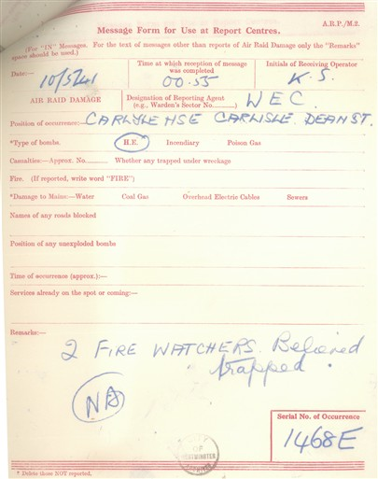  Occurrence 1468E | 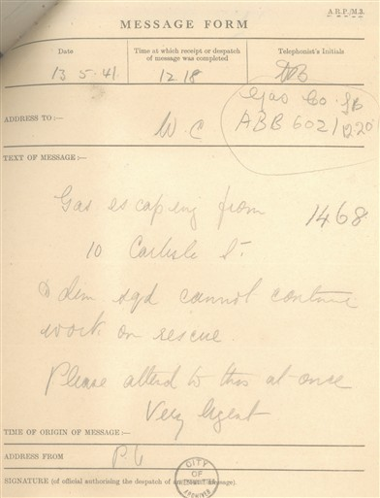  Gas escape message

Recorded details

Occurrence 1468E
Field | Transcription or reading
Date | 10 May 1941 as entered; the incident narrative dates the raid to 11 May
Receipt | 00:52
Position | Carlisle House, Carlisle Street × Dean Street
Bomb type | High explosive
Remarks | “2 fire watchers reported trapped.”

Gas escape message
Field | Transcription or reading
Date | 13 May 1941
Receipt | 12:18
Text | “Gas escaping from 10 Carlisle St. Dem. squad cannot continue work on rescue. Please attend to this at once. Very urgent.”
From | P U [uncertain]

St James’s Residences Brewer Street
  - 26 October 1940 approximately midday
The archived account reports a high-explosive bomb on St James’s Residences in Brewer Street. It gives forty-five casualties in all: five dead, twenty ambulance cases and twenty First Aid Post cases. Rescue work continued for about six hours.
Archive source West End at War archived incident page

Surviving forms
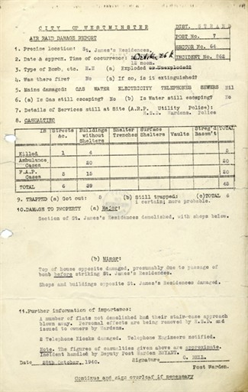  Air Raid Damage Report 862 | 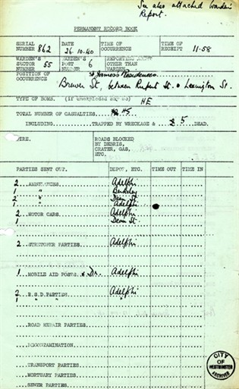  Permanent Record Book 862

Recorded details

Air Raid Damage Report 862
Field | Transcription or reading
Precise location | St James’s Residences, Brewer Street
Date | 26 October 1940
Bomb type | High explosive
Casualties | 45 total: 5 killed, 20 ambulance cases, 20 First Aid Post cases
Trapped | At least one; possibility of more
Major damage | Shop and buildings opposite St James’s Residences damaged.
Further information | Rescue work continued about six hours; casualties were being removed by ambulance and stretcher-bearer parties [typed report].

Permanent Record Book 862
Field | Transcription or reading
Date | 26 October 1940
Occurrence | 11:58
Position | Brewer Street, between Rupert Street and Lexington Street [reading probable]
Bomb type | High explosive
Casualties | 5
Resources | Ambulances, stretcher parties, mobile aid post and rescue squad entries recorded; several are marked “awaiting.”

The page listed a third image, 862b.jpg, but no archived copy was found in the Wayback capture index. This is a confirmed gap rather than an omitted transcription.

Shaftesbury Avenue Fire Station
  - 7 October and 16 November 1940
The 7 October record concerns the fire station at Newport Place and Shaftesbury Avenue. The archived narrative says the station was virtually demolished, fire engines were buried and entrances blocked; two passers-by sheltering at the doorway were killed. A separate damage report records the later incident at 95 Shaftesbury Avenue.
Archive source West End at War archived incident page

Surviving forms
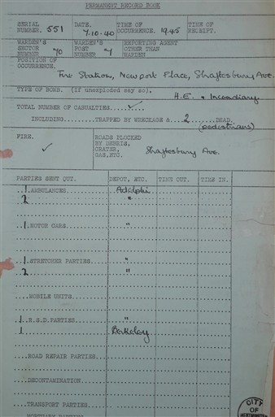  Permanent Record Book 851 | 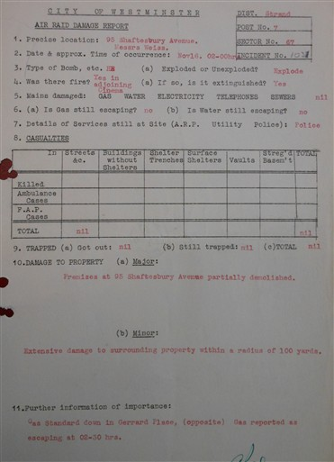  95 Shaftesbury Avenue damage report

Recorded details

Permanent Record Book 851
Field | Transcription or reading
Date | 7 October 1940
Occurrence | 19:45
Position | Fire Station, Newport Place, Shaftesbury Avenue
Bomb type | High explosive; “incendiary” also written
Casualties | 2 dead, identified as pedestrians
Roads blocked | By debris in Shaftesbury Avenue
Resources | Ambulance and rescue squad entries recorded; “Berkeley” appears beside rescue squad.

95 Shaftesbury Avenue
Field | Transcription or reading
Date and time | 16 November 1940, 02:00
Bomb type | High explosive; exploded
Services still on site | Police
Casualties | Nil
Major damage | Premises at 95 Shaftesbury Avenue partly demolished.
Minor damage | Extensive damage to surrounding property within a radius of 100 yards.
Further information | Gas reported escaping at 02:30 from a Standard Oil premises opposite.

Café de Paris
  - 8 March 1941
This requested exception survives on West End at War as a narrative page rather than a set of warden report forms. The page states that two bombs passed through the roof of the Café de Paris in Coventry Street, killing at least thirty-four people and injuring about eighty. Bandleader Ken “Snakehips” Johnson was among those killed. It describes rescue workers operating for roughly three hours in very poor light and wardens chasing looters.
Archive source West End at War archived Café de Paris page
Evidence status This section is a transcriptional summary of the website narrative. No original warden message-form image was found attached to the archived page.

Later recollections
Comments preserved with the page include later family and eyewitness recollections. They are useful leads but are not contemporary incident reports. The same comment thread correctly distinguishes Al Bowlly’s death from the Café de Paris raid.

Jermyn Street and Al Bowlly
  - 17 April 1941 approximately 03:10 onward
A parachute mine devastated buildings around Jermyn Street, including the Hammam Baths and number 50, with widespread damage around Duke Street St James’s. The site records twenty-three people injured and seven killed, including singer Al Bowlly. The archive page notes competing versions of the precise mechanism of his death; the secure point is that he died at Dukes Court in the blast from the nearby mine.
Archive source West End at War archived Jermyn Street page

Surviving forms
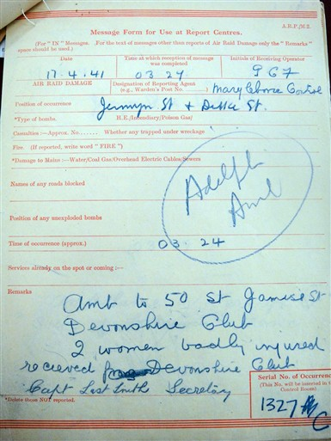  Devonshire Club ambulance request | 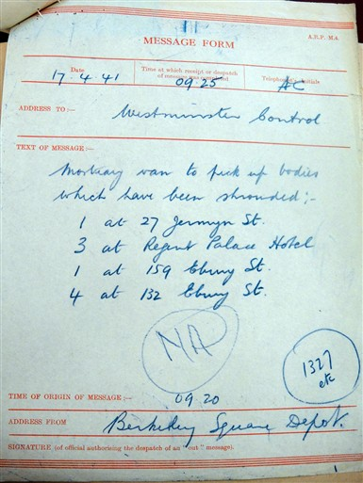  Casualty collection message
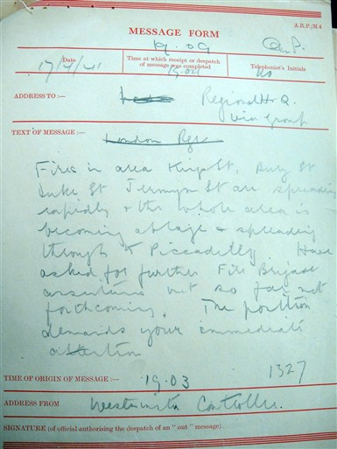  Evening fire report | 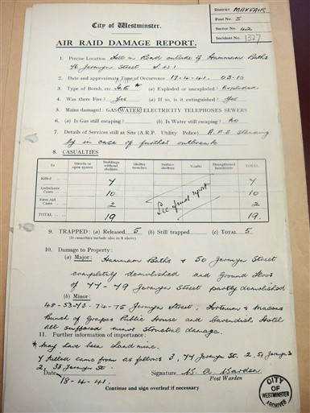  Air Raid Damage Report 1327

Recorded details

Devonshire Club request
Field | Transcription or reading
Date | 17 April 1941
Receipt | 03:24
Position | Jermyn Street × Duke Street
Occurrence | 03:24
Remarks | “Amb. to 50 St James’s St, Devonshire Club. 2 women badly injured … Devonshire Club.” [middle words unclear]

Casualty pickup message
Field | Transcription or reading
Date | 17 April 1941
Receipt | 09:25
From | Berkeley Square Depot
Text | Mortuary van to pick up bodies: 1 at 27 Jermyn Street; 3 at Regent Palace Hotel; 1 at 59 Albany Street; 4 at 132 Albany Street.

Fire spread message
Field | Transcription or reading
Date | 17 April 1941
Origin | 19:03
From | Westminster Control
Text | Fire in the area of the upper part of Duke Street and Jermyn Street is spreading; further Fire Brigade assistance requested [partial transcription].

Air Raid Damage Report 1327
Field | Transcription or reading
District | Mayfair
Post | 5
Date and time | 17 April 1941, 03:10
Bomb type | High explosive / parachute mine [form marks are difficult to separate]
Main affected buildings | Hammam Baths and 50 Jermyn Street completely demolished; ground storeys of 47–49 Jermyn Street partly demolished.
Casualties | 19 entered in the report table; the website’s cumulative total is 23 injured and 7 killed.
Trapped | 5 released [form reading]
Further information | Heavy damage extending through Duke Street and Jermyn Street; handwritten address list continues below the main damage description.

Cross-check English Heritage’s Al Bowlly plaque account says he was one of three Dukes Court residents killed by the blast of a landmine in nearby Jermyn Street. It does not repeat the website’s more specific bedroom-door anecdote.

Archive source English Heritage Al Bowlly plaque account

Editorial notes

What has been transcribed
Dates, times, locations, bomb type, casualty status, services and remarks have been transcribed where the web-sized image supports a reasonable reading. Typed damage reports are generally clearer than handwritten message forms. Initials and routing marks are omitted unless they help identify the source or sequence.

Uncertainty convention
Square brackets indicate an editorial expansion, qualification or uncertainty. “Unclear” means the preserved image does not support a dependable reading. “Partial transcription” means the operational sense is visible but one or more words remain doubtful. Quotation marks are used only where the words can be read with confidence.

Scope boundary
The dossier is deliberately limited to Soho and its immediate West End edge. The Café de Paris and Al Bowlly material is included by request. Other West End at War warden narratives, including E Ita Ekpenyon’s St Marylebone account, are not reproduced because they fall outside the agreed area.

Next reconstruction stage
The scans provide enough evidence to recreate the visual system of the forms—red rules, serif headings, field hierarchy and handwritten overlays—without pretending that missing text has been recovered. A later facsimile set should retain the transcript and the reconstructed artwork as separate layers.

